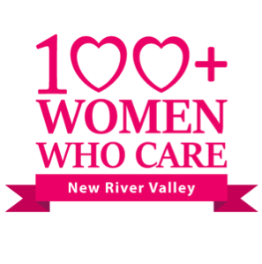
CHARITABLE ORGANIZATION FACT SHEET
Please submit this completed form to nrv100wwc@gmail.com for approval at least two days prior to the next meeting.
All organizations up for consideration should have tax-deductible non-profit 501(c)(3) status, serve the New River Valley area, and be non-controversial.
MEMBER SPONSOR NAME: ___________________________________ DATE: ________________

1. Name of organization and EIN (Please provide legal name that can be verified through Charity Navigator and the IRS):

2. Physical address (Headquarters and where services are provided, if different):

3. Social media sites (website, Facebook, etc.):

4. When was the organization founded?

5. What is its mission statement?

6. How would donated funds be used? Why would a contribution from the 100+ WWC be critical to the organization’s mission?

7. What are the current sources of funding for the organization? Be prepared to answer financial questions related to overhead, budget, expenses, etc.

8. What population does the organization serve (children, women, elderly, disabled, etc.), and how many people receive services annually?

9. Is the organization a registered 501(c)(3) (IRS Certified Tax Free Status) charitable corporation? NOTE: A non-501(c)(3) organization is still eligible for consideration; however, contributions from 100+ WWC members will not be tax deductible, and members must be aware of this caveat prior to voting.

10. If selected, would someone from the organization be available to speak at the next quarterly meeting to describe the impact of the donated funds?
Yes No

11. Does the organization agree not to sell, give, or use the 100+ WWC members’ contact information for additional solicitations by themselves or other organizations?
Yes No

12. Summarize the organization in two sentences.

